E-News

An Overview of Common Electrical Safety Test Requirements

Manufacturers of electrical products cannot prevent consumers from improperly using their products or from defeating safety ground systems. They only can warn them of the risks. On the other hand, products with faulty insulation must not leave a manufacturing or repair facility.

The greatest concern is the insulation that separates the power-line circuit from everything else. Current flows into any available ground path because power-distribution systems are ground-referenced. Insulation prevents current from becoming hazardous by finding a ground path with something that is not meant to be a ground path-such as a human body.

International safety testing agencies such as the Underwriters Laboratories (UL), the Canadian Standards Association, the Association of German Electrical Engineers (VDE) and (TÜV), and the International Electro technical Commission (IEC) specify dozens of safety tests for electrically operated products. Their primary purpose is to ensure that products meet worldwide standards for construction, electrical safety, ratings, markings and instruction manuals.

Four tests are most commonly used to verify electrical safety. They are line-leakage, insulation-resistance (IR), ground-bonding and dielectric-withstand or HiPot testing.

Line-Leakage Tests

Various studies have shown that the human body's threshold for perceiving electric current is approximately 1 mA. Once current exceeds a person's threshold, it can cause a startle reaction, an uncontrolled muscular spasm induced by a sudden, unexpected electrical shock. Because of the potential hazards these low-level currents present to the human body, safety agencies and other private and governmental testing agencies have set standards for the maximum amount of current that may leak from a non- defective product operating at its normal line voltage.

The leakage-current test (sometimes referred to as line-leakage test) determines if the leakage current is within acceptable limits. Line-leakage tests on most appliances usually are specified only as type tests and not required as a routine production-line test on every item before it is shipped. This is largely because the amount of leakage primarily is determined by the product's design.

Medical-device manufacturing is one industry where line-leakage testing is commonly done as a production-line test. This stems from the increased risks associated with these types of products.

Medical devices usually are used on patients who would be more susceptible to shock risks because they are in poor health. To accurately measure the available leakage currents that a person may be exposed to, the measuring instrument must simulate the impedance of the human body (Figure la).
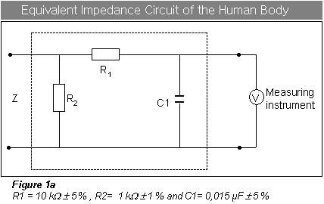
Tests for leakage must be performed on the protective earth or ground conductor, the enclosure and any patient-connected devices. The leakage-current limits vary from 0.01 mA to 5 mA depending on the test being performed.

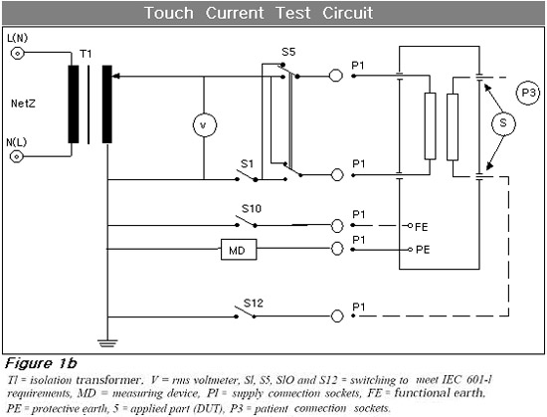
First, the tests are conducted with normal line and neutral connections to the device under test (DUT), and then with these connections reversed to simulate the DUT being powered by an improperly wired receptacle. The line-leakage tests also must be performed with an open ground, neutral or hot connection. Figure lb shows a typical switching circuit for performing line-leakage tests as specified in IEC 60l- 1.

The IEC 601 - 1 specification is being adopted as an international standard for testing medical devices. Other specifications harmonized with IEC 601-1 include UL 2601 and EN 60601. As of January 1997, any manufacturer of medical devices must meet the requirements of IEC 601-l as part of compliance to the Low-Voltage Directive to ship their products into the European Community. The Low-Voltage Directive is a standard adopted by the European Community as part of the requirements for ensuring the electrical safety of products that are shipped to or manufactured within Europe.

Insulation-Resistance Testing

IR is the least commonly specified of all the electrical safety tests because dielectric-withstand tests stress the same insulation system and are more complete. An insulation-resistance test can provide quantitative data as an actual resistance reading of the insulation system. The most common test voltages specified by safety agencies are either 500 VDC or 1,000 VDC.

Measuring IR is straightforward. The IR tester is connected between two points separated by insulation and a measurement is taken. The measured value represents the equivalent resistance of all the insulation that exists between the two points and any component resistance that might be connected between the two points.

IR tests are more commonly used on products containing windings such as motors, transformers and generators. These products contain wound insulation and an IR test has proven useful for testing newly wound insulation after servicing as well as for preventative-maintenance purposes.

Ground-Bond Testing

The ground-bond test or ground-impedance test determines whether the safety ground circuit of the DUT can adequately handle fault current in case the product's insulation becomes defective. Should a product fail, a low-impedance ground system is essential to ensure that a circuit breaker or fuse on the input line will act quickly enough to protect the user from receiving a dangerous electrical shock.

To prevent electrical shock, there must be continuity between the conductive parts of a product and the ground/earth wire of the line cord or the ground terminal. By grounding the exposed metal parts, all normal leakage current is routed safely to ground and does not flow through the user.

Some international-compliance agencies such as IEC require a ground-bond test on all DUTs as they leave the production line. Do not confuse this test with simple low-current continuity tests. A low-current continuity test only indicates that there is a safety ground connection, but it does not completely test the integrity of that connection.

For example, a ground-continuity test may not detect a ground connection that consists of only a few strands of wire. To test for a good bond of the DUT's ground system in a production environment, an instrument must provide the required low-voltage output current through the DUT's safety ground. At the same time, the instrument must measure the induced voltage across the safety ground circuit to determine the impedance of the ground connection.

The most common requirements call for resistance measurements somewhere in the range of 100 mΩ to 200 mΩ .The applied current usually is in the range of 10 A to 25 A. Voltage for this test most often is specified as less than 12 V.

The measured values usually are so low that you should be careful not to read the resistance of the test leads that are used to connect the test instrument to the DUT. Otherwise, it might be erroneously concluded
that the DUT has a safety ground failure.

Dielectric-Withstand Test

The dielectric voltage withstand test, or HiPot (high-potential test), stresses insulation far beyond what it will encounter during normal use. If the insulation can withstand the much higher voltage for a given period of time, it should function adequately at its operating voltage level. Thus, the term voltage-withstand test.

In addition to overstressing the insulation, the test detects material and workmanship defects, such as conductor spacing that are too close. When a product operates under normal conditions, environmental factors such as humidity, dirt, vibration, shock and contaminants can close these small spacing and allow current to flow. This can create a shock hazard if these defects are not corrected at the manufacturing facility. No other test uncovers this type of defect as well as the HiPot test.

Safety testing agencies require HiPot testing to verify that a product meets their standards at the design stage. The HiPot test also is one of the few tests required by all agencies as a production-line test on every product before it is shipped.

Another requirement driving product-safety testing is the need for manufacturers selling products to Europe ‘to comply with CE regulations. These regulations call out requirements for performing a variety of electrical safety tests to meet the safety compliance requirements for the Low-Voltage Directive.

During a HiPot test, the dielectric circuit of any DUT can be broken into three basic components. The dielectric circuit consists of the DUT's capacitance (C), insulation resistance (R L) and series or contact resistance (R A).

The specified test voltage is seldom less than 1,000 V. For some products intended to operate at voltages between 100 V and 240 V, the test voltage can exceed 4,000 V.

Most safety agencies use a rule of thumb to determine the appropriate test voltage. Multiply the DUT's normal operating voltage by 2 and add 1,000 V. Agency requirements also take into consideration the product's intended use and operating environment.

Many standards specify the amount of time high voltage must be applied during testing. The most commonly specified test times are either 1 s or 1 min. AC voltage is specified more often than DC because it is felt that AC voltage stresses the insulation in a way similar to how the product will be used.

Failure During a Hipot Test

Dielectric breakdown may be defined as the failure of insulation to effectively prevent the flow of current, sometimes evidenced by arcing. If voltage is raised gradually, breakdown will begin at a certain voltage level (where current flow is not directly proportional to voltage). When breakdown current flows, especially for a period of time, the next gradual application of voltage often will show a breakdown beginning at a lower voltage than initially measured.

Excessive leakage current may be defined as AC or DC current flow through insulation and over its surfaces and AC current flow through a capacitance (where current flow is directly proportional to voltage). If breakdown does not occur, the insulation and capacitance are considered a constant impedance. Most instruments have adjustable thresholds for leakage below which they will not indicate a leakage failure.

Arc failure is a condition where voltage discharges across or through the insulation and causes excessive current flow. Sometimes for diagnostic or development reasons, it may be necessary to determine if minute arcing is occurring.

A high-frequency signal appears on the AC voltage sine wave when a low-level arcing condition occurs. This low-level arcing is not of sufficient current flow or time duration to indicate failure on traditional failure circuits of many HiPot testers. In many specifications, UL states that this sporadic low-level arcing should be ignored for purposes of production line testing.

Summary

It is impossible to ensure that consumers will always use products safely or that they will not defeat safety systems. However, if products meet agency requirements for electrical safety and have been tested with an instrument that performs these safety tests, you have met your obligation as a responsible supplier by doing everything in your power to ensure that your products are electrically safe.

